**WeatherPy Analysis by Alex Koynoff**

**Observation 1:** Based on the random sample of 500+ cities, it looks like the max temperature tends to be lower when it is above the equator during this time of the year (April 2019). For example, when comparing 40 degrees below and above the equator, the temperature seems to be higher when below the equator compared to above the equator.

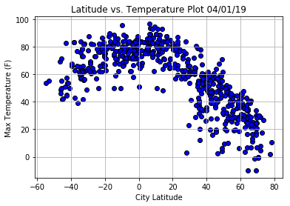

**Observation 2:** Based on the random sample of 500+ cities,the wind speed tends to be slightly higher for cities that are above the equator, compared to below the equator during the time of this sample, April 2019. This can be seen in the higher number of cities that are above 20 mph, located above the equator.

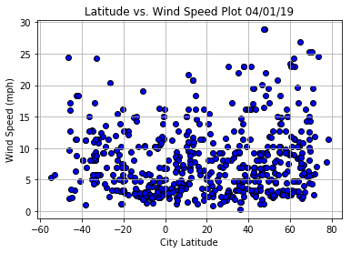

**Observation 3:** Based on the random sample of 500+ cities during the time the sample was taken, April 2019, humidity levels for cities above the equator can go to less than 20%, while none of the cities in the sample that are located below the equator dip below 20% humidity level.

